Program

🌟 Definition
# Source: AI Source: Provided by: [Data Path: Persons Table -> ID Column: 1, Name_En Column: Motasem Essam] -> From: [ChatGPT] on [6/7/2026]
A Program is a set of instructions written in a programming language that performs a specific task or solves a particular problem when executed by a computer.
A program is created from code and can be run by users or other software.

🎯 Simple Definition
# Source: AI Source: Provided by: [Data Path: Persons Table -> ID Column: 1, Name_En Column: Motasem Essam] -> From: [ChatGPT] on [6/7/2026]
Program = Executable Code That Performs a Task
Examples:
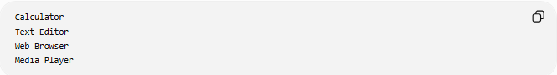
Calculator
Text Editor
Web Browser
Media Player
Each of these is a program.

🧠 Real-World Analogy
# Source: AI Source: Provided by: [Data Path: Persons Table -> ID Column: 1, Name_En Column: Motasem Essam] -> From: [ChatGPT] on [6/7/2026]
Think of a recipe.
Recipe
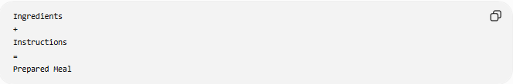
Ingredients
+
Instructions
=
Prepared Meal

Software
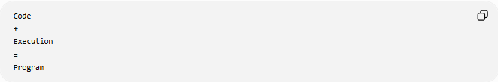
Code
+
Execution
=
Program
The program is the working result of the code.

🔄 How a Program Works
# Source: AI Source: Provided by: [Data Path: Persons Table -> ID Column: 1, Name_En Column: Motasem Essam] -> From: [ChatGPT] on [6/7/2026]
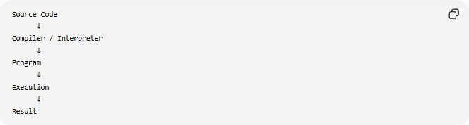
Source Code
↓
Compiler / Interpreter
↓
Program
↓
Execution
↓
Result

📚 Example Program
# Source: AI Source: Provided by: [Data Path: Persons Table -> ID Column: 1, Name_En Column: Motasem Essam] -> From: [ChatGPT] on [6/7/2026]
PHP Program
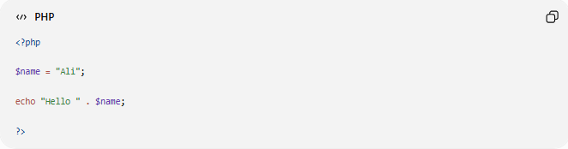
<?php
$name = "Ali";
echo "Hello " . $name;
?>
Output:
Hello Ali

Python Program
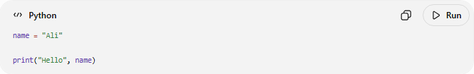
name = "Ali"
print("Hello", name)
Output:
Hello Ali

🧩 Components of a Program
# Source: AI Source: Provided by: [Data Path: Persons Table -> ID Column: 1, Name_En Column: Motasem Essam] -> From: [ChatGPT] on [6/7/2026]
A program usually contains:

1️⃣ Variables
# Source: AI Source: Provided by: [Data Path: Persons Table -> ID Column: 1, Name_En Column: Motasem Essam] -> From: [ChatGPT] on [6/7/2026]
Store data.
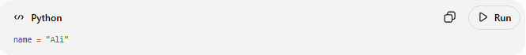
name = "Ali"

2️⃣ Functions
# Source: AI Source: Provided by: [Data Path: Persons Table -> ID Column: 1, Name_En Column: Motasem Essam] -> From: [ChatGPT] on [6/7/2026]
Perform reusable tasks.
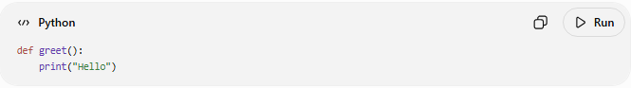
def greet():
print("Hello")

3️⃣ Conditions
# Source: AI Source: Provided by: [Data Path: Persons Table -> ID Column: 1, Name_En Column: Motasem Essam] -> From: [ChatGPT] on [6/7/2026]
Make decisions.
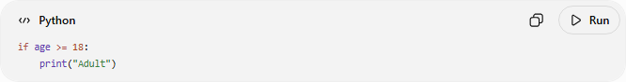
if age >= 18:
print("Adult")

4️⃣ Loops
# Source: AI Source: Provided by: [Data Path: Persons Table -> ID Column: 1, Name_En Column: Motasem Essam] -> From: [ChatGPT] on [6/7/2026]
Repeat actions.
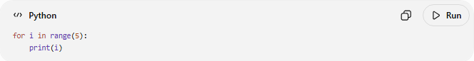
for i in range(5):
print(i)

5️⃣ Input and Output
# Source: AI Source: Provided by: [Data Path: Persons Table -> ID Column: 1, Name_En Column: Motasem Essam] -> From: [ChatGPT] on [6/7/2026]
Receive and display data.
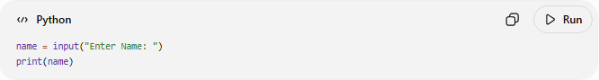
name = input("Enter Name: ")
print(name)

📂 Types of Programs

System Programs
# Source: AI Source: Provided by: [Data Path: Persons Table -> ID Column: 1, Name_En Column: Motasem Essam] -> From: [ChatGPT] on [6/7/2026]
Help operate the computer.
Examples:
- Operating systems
- Device drivers
- Utility tools
Example:
- Microsoft Windows
- Ubuntu

Application Programs
# Source: AI Source: Provided by: [Data Path: Persons Table -> ID Column: 1, Name_En Column: Motasem Essam] -> From: [ChatGPT] on [6/7/2026]
Used by end users.
Examples:
- Microsoft Word
- Google Chrome
- Adobe Photoshop

Web Programs
# Source: AI Source: Provided by: [Data Path: Persons Table -> ID Column: 1, Name_En Column: Motasem Essam] -> From: [ChatGPT] on [6/7/2026]
Run on web servers.
Examples:
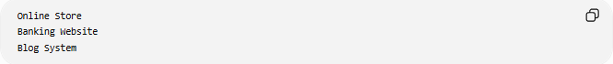
Online Store
Banking Website
Blog System

Mobile Programs
# Source: AI Source: Provided by: [Data Path: Persons Table -> ID Column: 1, Name_En Column: Motasem Essam] -> From: [ChatGPT] on [6/7/2026]
Run on smartphones.
Examples:
- WhatsApp
- Instagram

📊 Program vs Code
# Source: AI Source: Provided by: [Data Path: Persons Table -> ID Column: 1, Name_En Column: Motasem Essam] -> From: [ChatGPT] on [6/7/2026]
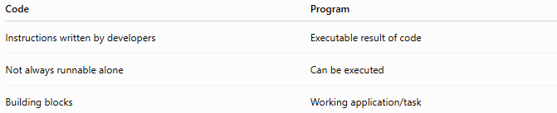
Code | Program
Instructions written by developers | Executable result of code
Not always runnable alone | Can be executed
Building blocks | Working application/task

Example:
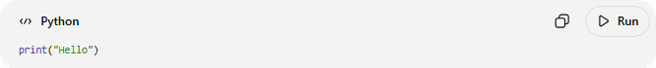
print("Hello")
This is code.
When executed:
Hello
It becomes part of a running program.

📊 Program vs Software
# Source: AI Source: Provided by: [Data Path: Persons Table -> ID Column: 1, Name_En Column: Motasem Essam] -> From: [ChatGPT] on [6/7/2026]
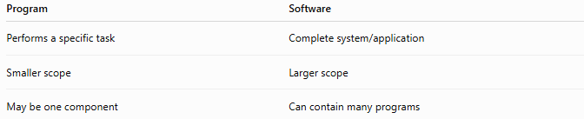
Program | Software
Performs a specific task | Complete system/application
Smaller scope | Larger scope
May be one component | Can contain many programs

Example:
Calculator Program
vs
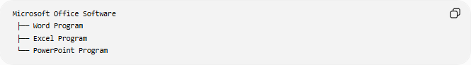
Microsoft Office Software
├── Word Program
├── Excel Program
└── PowerPoint Program

📊 Program vs Script
# Source: AI Source: Provided by: [Data Path: Persons Table -> ID Column: 1, Name_En Column: Motasem Essam] -> From: [ChatGPT] on [6/7/2026]
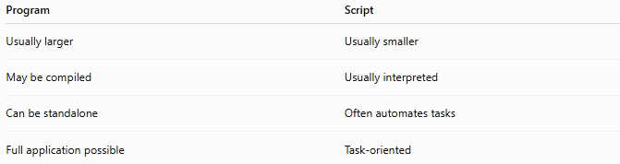
Program | Script
Usually larger | Usually smaller
May be compiled | Usually interpreted
Can be standalone | Often automates tasks
Full application possible | Task-oriented

Example Script:
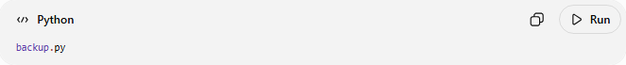
backup.py
Automates backups.

Example Program:
Accounting Application
Complete business software.

🌍 Real-World Examples
# Source: AI Source: Provided by: [Data Path: Persons Table -> ID Column: 1, Name_En Column: Motasem Essam] -> From: [ChatGPT] on [6/7/2026]
Calculator Program
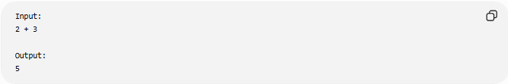
Input:
2 + 3
Output:
5

ATM Program
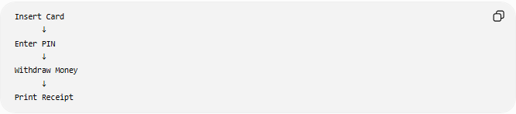
Insert Card
↓
Enter PIN
↓
Withdraw Money
↓
Print Receipt

E-Commerce Program
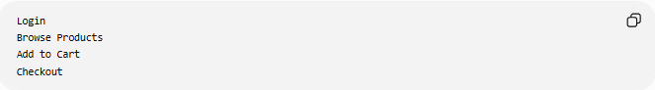
Login
Browse Products
Add to Cart
Checkout

🛠️ Programming Languages Used to Create Programs
# Source: AI Source: Provided by: [Data Path: Persons Table -> ID Column: 1, Name_En Column: Motasem Essam] -> From: [ChatGPT] on [6/7/2026]
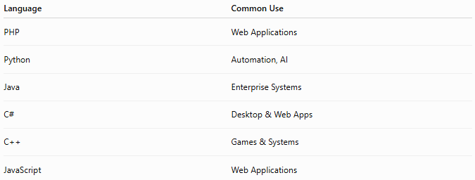
Language | Common Use
PHP | Web Applications
Python | Automation, AI
Java | Enterprise Systems
C# | Desktop & Web Apps
C++ | Games & Systems
JavaScript | Web Applications

🧠 Simple Analogy
# Source: AI Source: Provided by: [Data Path: Persons Table -> ID Column: 1, Name_En Column: Motasem Essam] -> From: [ChatGPT] on [6/7/2026]
Imagine a car factory.
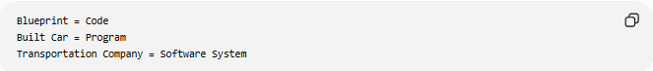
Blueprint = Code
Built Car = Program
Transportation Company = Software System
The program is the working product created from the code.

🧭 Summary
# Source: AI Source: Provided by: [Data Path: Persons Table -> ID Column: 1, Name_En Column: Motasem Essam] -> From: [ChatGPT] on [6/7/2026]
A Program is an executable set of instructions written in a programming language that performs a specific task. Programs are created from source code and can range from simple calculators to complex business applications. They contain components such as variables, functions, conditions, loops, and input/output operations. Programs are the bridge between code and complete software systems, turning written instructions into useful functionality for users.

